**Git HOL – 2**

**Questions & Answers –**

1. **Explain git ignore**

**Ans -** gitignore is a special file used by Git to tell it which files or directories to ignore in a project. This means Git will not track changes to those files, will not stage them, and will not commit them.

This is useful for:

* Ignoring temporary files, like log files, cache, or IDE settings.
* Preventing sensitive info (e.g., passwords or API keys) from being committed.
* Avoiding clutter in your repository with files that are not relevant to source control.

1. **Explain how to ignore unwanted files using git ignore**

**Ans –** To ignore unwanted files using gitignore we follow the following steps –

1. Create a.gitignore File
2. Add Patterns of Files/Folders to Ignore

Ex –

# Node modules

node_modules/

# Environment variables

.env

# Logs

*.log

# Build output

dist/

build/

# System files

.DS_Store

Thumbs.db

**Created the folders/files to be ignored**

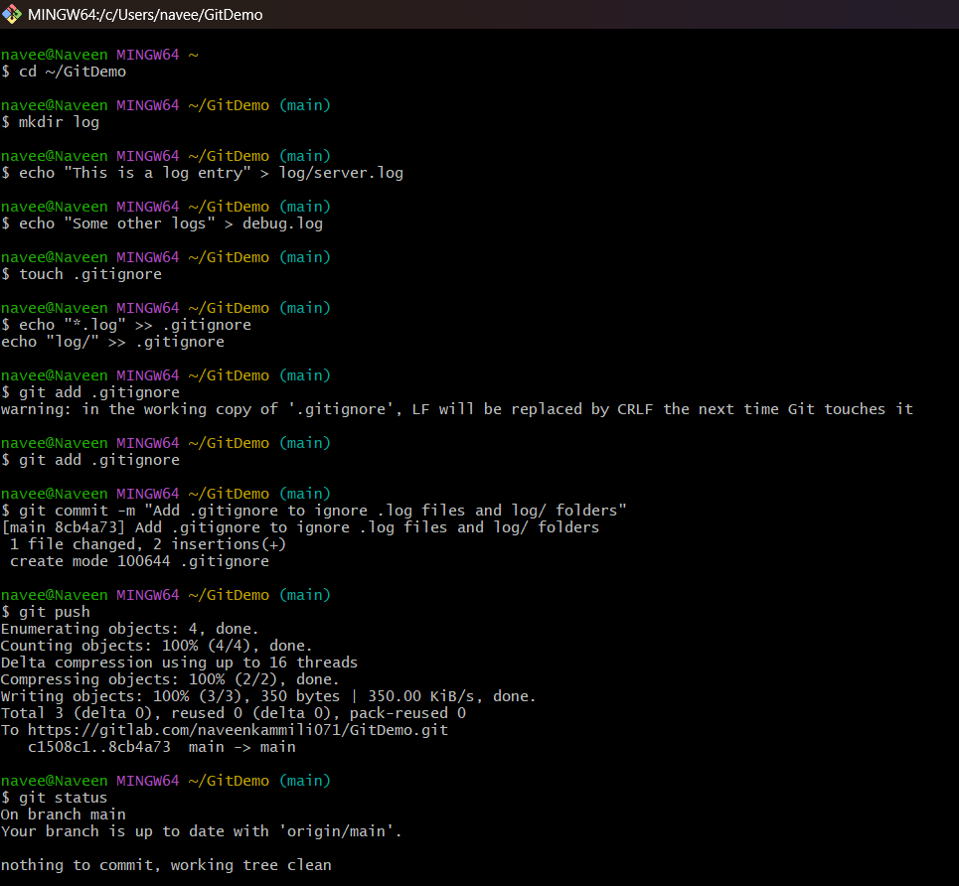

**.gitignore file is pushed –**

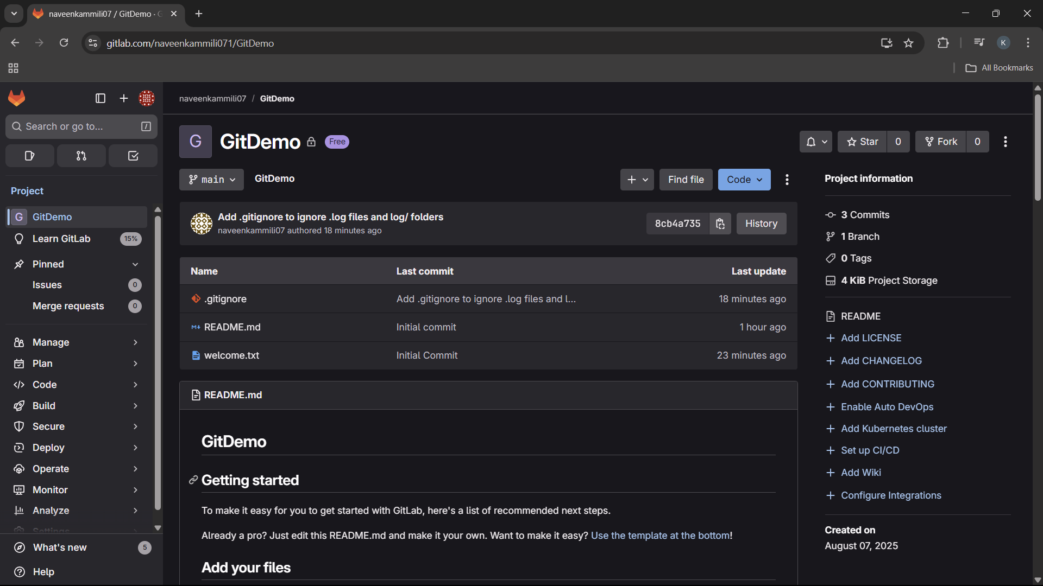

**These files are ignored**

